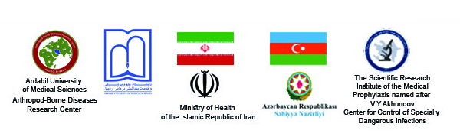
International Webinar Program

Title: The Epidemiology of Dengue Fever and Aedes Mosquitoes

No | Presenter | Topic | Time | Session
1 | Dr.Behzad Davarnia | Welcome and Introduction | 9.00 -9.10 | Opening Session
2 | Prof.Adil Allahverdiyev | Welcome and Introduction | 9.10 -9.20 | Opening Session
3 | Prof. Shahram Habibzadeh | On Health in the Control System for Human and Dengue Fever Vectors in Iran | 9.20 -9.50 | Scientific Presentation I
4 | Dr. Rita Ismayilova | Current epidemiological situation regarding dengue fever in Azerbaijan | 9.50 – 10.20 | Scientific Presentation II
5 | Prof.Ahmad Raisi | Integrated Health and Dengue Fever | 10.20 – 10.50 | Scientific Presentation III
6 | Dr. Namazov Nasib | Entomofauna of mosquitoes of the genus Aedes in the Republic of Azerbaijan | 10.50 – 11.20 | Scientific Presentation IIII
7 | Dr.Eslam Moradi-Asl | Questions and Answers with Speakers | 11.20 – 13.00 | Discussion
8 | Dr. Lala Rustamova | Questions and Answers with Speakers | 11.20 – 13.00 | Discussion
Ardabil University of Medical Sciences

